TrafficRush

Game Design Document

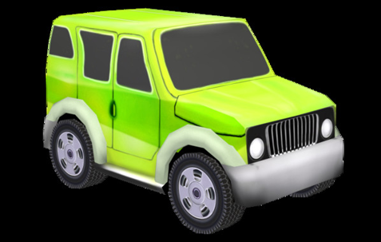

Created Through Unity

**Game Overview:**

**Title:** TrafficRush

**Platform:** PC/Mac Standalone

**Genre:** Endless arcade racing

**Rating:** G

**Target:** Casual gamer (aging from 12 - 30)

**Release Date:** May 8th, 2019

**Publishers:** Colin Waters, Youssef Iraqi, Brian Rafferty, Jose Untalan

TrafficRush is a traffic racing game, in which you play as the driver of a car going down an endless road. The road has many cars going in both directions that the player must avoid. If the player’s car touches another car, the players health will drop, and the car will ultimately be destroyed. Additionally, there is various other obstacles the player must avoid as they traverse the road. The player must get as far as possible to get the highest score possible.

**Unique Selling Points:**

• Fun and easy to hop into

• Simple controls

• Replayability

**Platform Requirements:**

Any computer built after 2004 and running Windows/OSX should be able to run TrafficRush easily.

**Game Objective:**

The objective of the game is to get as far as possible down the road and in turn achieve the highest score possible.

**Game Rules:**

The game level is a closed environment, the road. The Player can drive anywhere they wish within the bounds of the road but must be careful to avoid the other cars and obstacles. The other cars are driving in both directions on the road and at different speeds. The player’s health will go down if a car or obstacle is touched and they will lose if their health reaches zero. The player must drive as long as possible and as far as possible.

**Game Structure:**

Menu Screen 🡪 Main Level 🡪 Gameover Screen

The menu screen will contain a button to reach the instructions for the game, a button to exit the game, and a button to access the main level of the game. Once the player loses the game, they are sent to a gameover scene and given the option to quit or try again.

**Game Controls:**

The player will use the Arrow Keys on their keyboard to drive the car. The Up Arrow Key moves the car forward. The Down Arrow Key causes the car to break and once stopped, move backward. The Left and Right Arrow Keys cause the car to turn left and right while moving forward or backward.

**Game Camera**

When the game starts, the camera will focus on the player and follow the player as they drive down the road. The camera will move forward and backward as the player does, but it will not rotate when the player turns the car.

**HUD:**

The HUD will consist of two items: The health bar that displays the health of the player throughout the session. The score text that displays the player’s score throughout the session.

**Player:**

The player is the driver of a car travelling down the road. The player controls the car and is given a health bar that tracks the health of the car until it is destroyed.

**Player States:**

**Idle:** The car does not move

**Move:** The movement animation will cause the car to drive forward or backward. It will be triggered when the player presses the Arrow Keys.

**Death:** The death animation will make the car explode and is triggered by the player’s health reaching zero.

**Enemy:**

The enemy is the cars that are also travelling in both directions down the road, as well as the other obstacles the player comes across on the road. If the player’s car touches any of these cars or obstacles, their health bar will drop. All of these enemies must be avoided as much as possible.

**Enemy States**

All Enemies possess the same behavior and states, as described below:

**Idle:** The Enemies play the Idle state, only when the Player is dead, while seeing the losing screen, and before restarting the level.

**Move:** While the Player is alive, all enemies will be in the Move state. The cars will be driving down the road and the obstacles will loop their animations.

**Level:**

The level is an endless road passing through a desert. The player and all of the enemies are on this road. The cars are driving down the road, similar to the player, and the other obstacles are spread out at various positions on the road.

**Audio:**

There are multiple sounds that are heard in the game. One is a constant song that is looped throughout the game. Another is an explosion sound that occurs when the player’s health reaches zero and the car is destroyed.

**Wishlist:**

• Additional levels with different themes

• Different vehicles encountered on the road

• More types of obstacles

• Powerups